Design database for Zen class programme
users
codekata
attendance
topics
tasks
company_drives
mentors

1.Find all the topics and tasks which are thought in the month of October
Answer:
Topics:
db.topics.find({thoughtDate:{$gte: ISODate("2020-10-01"),$lt: ISODate("2020-11-01")}})
Tasks:
db.tasks.find({thoughtDate:{$gte: ISODate("2020-10-01"),$lt: ISODate("2020-11-01")}})
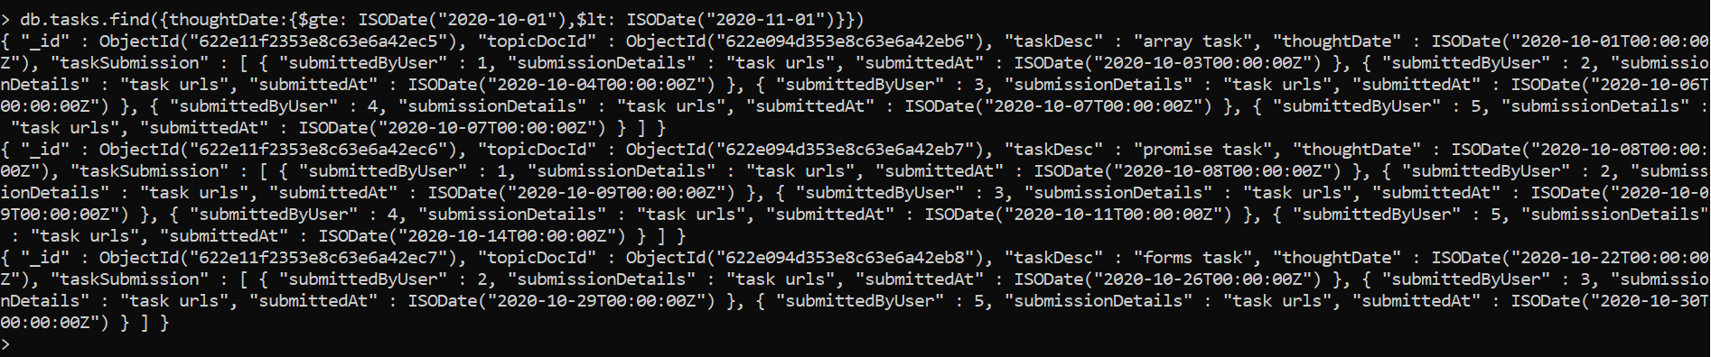

2.Find all the company drives which appeared between 15 oct-2020 and 31-oct-2020
Answer:
db.companydrives.find({driveDate:{$gte: ISODate("2020-10-15"),$lt: ISODate("2020-10-31")}})

3.Find all the company drives and students who are appeared for the placement.
Answer:
db.companydrives.aggregate([
{
$lookup: {
from: "users",
localField: "attendedByUserIDs",
foreignField: "_id",
as: "studentsAttendedPlacement"
}
},
{
$project : {
attendedByUserIDs : 0,
studentsAttendedPlacement : {educationDetails : 0, experienceDetails : 0, topicsAttended : 0, tasksSubmitted : 0},
}
}
])
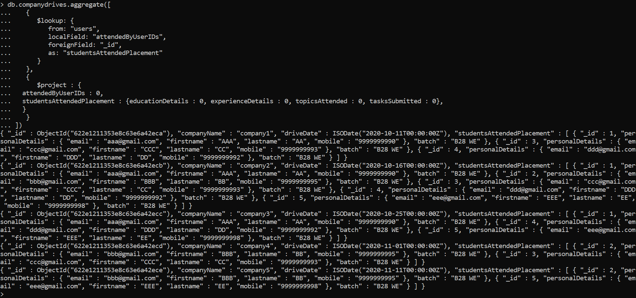

4.Find the number of problems solved by the user in codekata.
Answer:
db.codekata.aggregate([{$group : { _id : "$solvedByUser", count : { "$sum" : 1}}},{
$project: {
_id : 0,
userID : "$_id",
numberOfProblemsSolved : "$count"
}
}
])
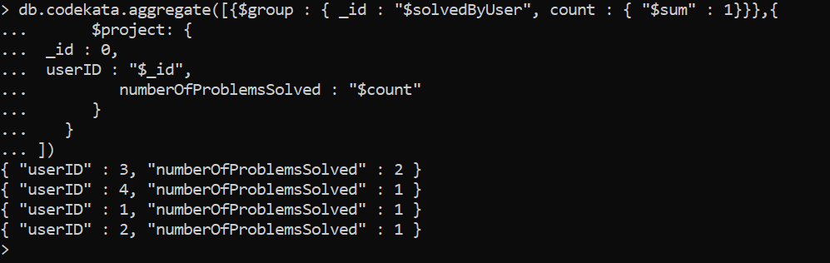

5.Find all the mentors with who has the mentee's count more than 15
Answer:
db.mentors.find({mentees_assigned : {$gt : 15}})

6.Find the number of users who are absent and task is not submitted between 15 oct-2020 and 31-oct-2020
Answer:
db.users.aggregate([{$match : {topicsAttended : {$nin :db.topics.find({thoughtDate:{$gte: ISODate("2020-10-15"),$lt: ISODate("2020-11-01")}}).map(function(p){return p._id})},tasksSubmitted : {$nin :db.topics.find({thoughtDate:{$gte: ISODate("2020-10-15"),$lt: ISODate("2020-11-01")}}).map(function(p){return p._id})}}},
{$group : { _id : null, count : { "$sum" : 1}}},{
$project: {
_id : 0,
numberOfUsersAbsentAndTaskNotSubmitted : "$count"
}
}
])
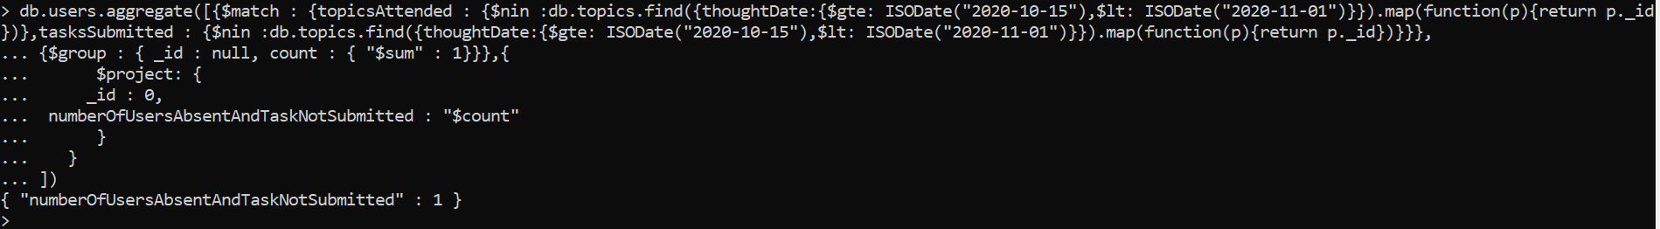

Data:
Users:
db.users.insertMany([{ _id : 1, personalDetails : {email : "aaa@gmail.com", firstname : "AAA", lastname : "AA", mobile : "9999999990"}, batch : "B28 WE", educationDetails : {qualification : "B.Tech IT", yearOfPassing : "2020"}, experienceDetails : {yearsOfExperience : 1, noticePeriod : "60 days"},topicsAttended:[ObjectId("622e094d353e8c63e6a42eb6"),ObjectId("622e094d353e8c63e6a42eb7"),ObjectId("622e094d353e8c63e6a42eb9"),ObjectId("622e094d353e8c63e6a42eba")],tasksSubmitted:[ObjectId("622e094d353e8c63e6a42eb6"),ObjectId("622e094d353e8c63e6a42eb7")]},
{ _id : 2, personalDetails : {email : "bbb@gmail.com", firstname : "BBB", lastname : "BB", mobile : "9999999995"}, batch : "B28 WE", educationDetails : {qualification : "B.E CSE", yearOfPassing : "2021"}, experienceDetails : {yearsOfExperience : 0, noticePeriod : ""}, topicsAttended:[ObjectId("622e094d353e8c63e6a42eb6"),ObjectId("622e094d353e8c63e6a42eb7"),ObjectId("622e094d353e8c63e6a42eb8"),ObjectId("622e094d353e8c63e6a42eb9")],tasksSubmitted:[ObjectId("622e094d353e8c63e6a42eb6"),ObjectId("622e094d353e8c63e6a42eb7"),ObjectId("622e094d353e8c63e6a42eb8"),ObjectId("622e094d353e8c63e6a42eb9")]},
{ _id : 3, personalDetails : {email : "ccc@gmail.com", firstname : "CCC", lastname : "CC", mobile : "9999999993"}, batch : "B28 WE", educationDetails : {qualification : "B.E EEE", yearOfPassing : "2021"}, experienceDetails : {yearsOfExperience : 0, noticePeriod : ""}, topicsAttended:[ObjectId("622e094d353e8c63e6a42eb6"),ObjectId("622e094d353e8c63e6a42eb7"),ObjectId("622e094d353e8c63e6a42eb8"),ObjectId("622e094d353e8c63e6a42eba")],tasksSubmitted:[ObjectId("622e094d353e8c63e6a42eb6"),ObjectId("622e094d353e8c63e6a42eb7"),ObjectId("622e094d353e8c63e6a42eb8")]},
{ _id : 4, personalDetails : {email : "ddd@gmail.com", firstname : "DDD", lastname : "DD", mobile : "9999999992"}, batch : "B28 WE", educationDetails : {qualification : "B.E ECE", yearOfPassing : "2019"}, experienceDetails : {yearsOfExperience : 2, noticePeriod : "60 days"}, topicsAttended:[ObjectId("622e094d353e8c63e6a42eb6"),ObjectId("622e094d353e8c63e6a42eb7"),ObjectId("622e094d353e8c63e6a42eb8"),ObjectId("622e094d353e8c63e6a42eba")],tasksSubmitted:[ObjectId("622e094d353e8c63e6a42eb6"),ObjectId("622e094d353e8c63e6a42eb7"),ObjectId("622e094d353e8c63e6a42eb9"),ObjectId("622e094d353e8c63e6a42eba")]},
{ _id : 5, personalDetails : {email : "eee@gmail.com", firstname : "EEE", lastname : "EE", mobile : "9999999998"}, batch : "B28 WE", educationDetails : {qualification : "B.E Mech", yearOfPassing : "2020"}, experienceDetails : {yearsOfExperience : 0, noticePeriod : ""}, topicsAttended:[ObjectId("622e094d353e8c63e6a42eb6"),ObjectId("622e094d353e8c63e6a42eb7"),ObjectId("622e094d353e8c63e6a42eb8"),ObjectId("622e094d353e8c63e6a42eb9")],tasksSubmitted:[ObjectId("622e094d353e8c63e6a42eb6"),ObjectId("622e094d353e8c63e6a42eb7"),ObjectId("622e094d353e8c63e6a42eb8"),ObjectId("622e094d353e8c63e6a42eba")]}])
Codekata:
db.codekata.insertMany([{category : 'Number', problemName : 'palindrome', solvedByUser : 1, solution : { solution : "", solvedAt : new Date('2020-10-01')}},
{category : 'Number', problemName : 'fibonacci series', solvedByUser : 2, solution : { solution : "", solvedAt : new Date('2020-10-11')}},
{category : 'String', problemName : 'reverse a string', solvedByUser : 3, solution : { solution : "", solvedAt : new Date('2020-11-01')}},
{category : 'Array', problemName : 'Duplicate elements', solvedByUser : 4, solution : { solution : "", solvedAt : new Date('2020-10-01')}},
{category : 'Number', problemName : 'palindrome', solvedByUser : 3, solution : { solution : "", solvedAt : new Date('2020-10-01')}}])

Attendance:
db.attendance.insertMany([{topicDocId : ObjectId("622e094d353e8c63e6a42eb6"), attendedByUser : [1,2,3,4,5]},
{topicDocId : ObjectId("622e094d353e8c63e6a42eb7"), attendedByUser : [1,2,3,4,5]},
{topicDocId : ObjectId("622e094d353e8c63e6a42eb8"), attendedByUser : [2,3,5]},
{topicDocId : ObjectId("622e094d353e8c63e6a42eb9"), attendedByUser : [1,2,4,5]},
{topicDocId : ObjectId("622e094d353e8c63e6a42eba"), attendedByUser : [1,3,4]}])

Topics:
db.topics.insertMany([{topicname : 'arrays and objects', programming_language : 'JS', thoughtDate : new Date('2020-10-01')},
{topicname : 'promise', programming_language : 'JS', thoughtDate : new Date('2020-10-08')},
{topicname : 'Basic elements and forms', programming_language : 'HTML', thoughtDate : new Date('2020-10-22')},
{topicname : 'Introducation and hooks', programming_language : 'React', thoughtDate : new Date('2020-11-01')},
{topicname : 'Router', programming_language : 'React', thoughtDate : new Date('2020-11-15')}])

Tasks:
db.tasks.insertMany([{topicDocId : ObjectId("622e094d353e8c63e6a42eb6"), taskDesc : "array task", thoughtDate : new Date('2020-10-01'), taskSubmission : [{submittedByUser: 1, submissionDetails:"task urls", submittedAt : ISODate('2020-10-03')},{submittedByUser: 2, submissionDetails:"task urls", submittedAt : ISODate('2020-10-04')},{submittedByUser: 3, submissionDetails:"task urls", submittedAt : ISODate('2020-10-06')},{submittedByUser: 4, submissionDetails:"task urls", submittedAt : ISODate('2020-10-07')},{submittedByUser: 5, submissionDetails:"task urls", submittedAt : ISODate('2020-10-07')},]},
{topicDocId : ObjectId("622e094d353e8c63e6a42eb7"), taskDesc : "promise task", thoughtDate : new Date('2020-10-08'), taskSubmission : [{submittedByUser: 1, submissionDetails:"task urls", submittedAt : ISODate('2020-10-08')},{submittedByUser: 2, submissionDetails:"task urls", submittedAt : ISODate('2020-10-09')},{submittedByUser: 3, submissionDetails:"task urls", submittedAt : ISODate('2020-10-09')},{submittedByUser: 4, submissionDetails:"task urls", submittedAt : ISODate('2020-10-11')},{submittedByUser: 5, submissionDetails:"task urls", submittedAt : ISODate('2020-10-14')}]},
{topicDocId : ObjectId("622e094d353e8c63e6a42eb8"), taskDesc : "forms task", thoughtDate : new Date('2020-10-22'), taskSubmission : [{submittedByUser: 2, submissionDetails:"task urls", submittedAt : ISODate('2020-10-26')},{submittedByUser: 3, submissionDetails:"task urls", submittedAt : ISODate('2020-10-29')},{submittedByUser: 5, submissionDetails:"task urls", submittedAt : ISODate('2020-10-30')}]},
{topicDocId : ObjectId("622e094d353e8c63e6a42eb9"), taskDesc : "hooks task", thoughtDate : new Date('2020-11-01'), taskSubmission : [{submittedByUser: 2, submissionDetails:"task urls", submittedAt : ISODate('2020-11-04')},{submittedByUser: 4, submissionDetails:"task urls", submittedAt : ISODate('2020-11-10')}]},
{topicDocId : ObjectId("622e094d353e8c63e6a42eba"), taskDesc : "router task", thoughtDate : new Date('2020-11-15'), taskSubmission : [{submittedByUser: 4, submissionDetails:"task urls", submittedAt : ISODate('2020-11-19')},{submittedByUser: 5, submissionDetails:"task urls", submittedAt : ISODate('2020-11-20')}]}])

Company drives:
db.companydrives.insertMany([{companyName : 'company1',attendedByUserIDs : [1, 3, 4], driveDate : new Date('2020-10-11')},
{companyName : 'company2',attendedByUserIDs : [1,2,3,4,5], driveDate : new Date('2020-10-16')},
{companyName : 'company3',attendedByUserIDs : [1,4,5], driveDate : new Date('2020-10-25')},
{companyName : 'company4',attendedByUserIDs : [2,3], driveDate : new Date('2020-11-01')},
{companyName : 'company5',attendedByUserIDs : [2,5], driveDate : new Date('2020-11-11')}])

Mentors:
db.mentors.insertMany([{email : 'mentor1@gmail.com', firstname : 'ZZZ', lastname : 'ZZ', mobile : '9999999989', mentees_assigned : 20},
{email : 'mentor2@gmail.com', firstname : 'YYY', lastname : 'YY', mobile : '9999999969', mentees_assigned : 14},
{email : 'mentor3@gmail.com', firstname : 'XXX', lastname : 'XX', mobile : '9999999929', mentees_assigned : 15},
{email : 'mentor4@gmail.com', firstname : 'WWW', lastname : 'WW', mobile : '9999999959', mentees_assigned : 22},
{email : 'mentor5@gmail.com', firstname : 'VVV', lastname : 'VV', mobile : '9999999979', mentees_assigned : 10}])

